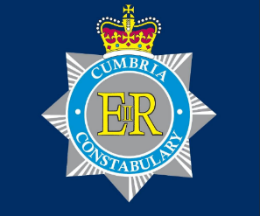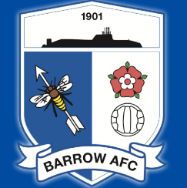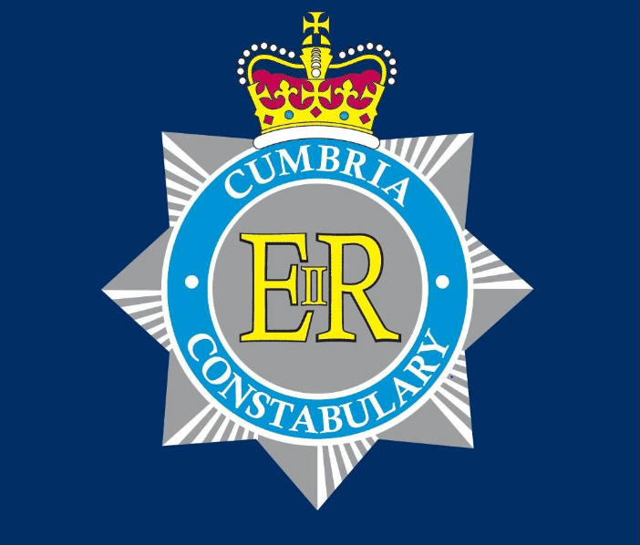

**CUMBRIA POLICE: BARROW FOOTBALL POLICING UNIT**

**VISITING SUPPORTERS INFORMATION**

**Tickets**

It is advisable to purchase tickets in advance, usually online or through the visiting club. Tickets on the day are available to purchase only if the original allocation has not been sold before the day of the match.

If you are purchasing on the day, then these can be bought from the ticket office shown on the picture below. We do not accept cash payments on the day. They can also be purchased online https://barrowafc.shop/match-tickets-portal/

All visiting supporters are situated in the Holker Street End with standing tickets are alongside the main stand. The maximum away capacity is 662 of which **112** are seated.

**All persons seeking entrance to the Stadium must acknowledge the Club's right to search any person entering, and to refuse entry to or eject any person refusing to undertake a search. This is supported by the police.**

**Getting to Holker Street Stadium**

Whether you are travelling from the North or South on the M6, leave the motorway at Junction 36, which is signposted for Barrow.

Continue to follow the signposts for Barrow and the journey will take around 30-40 minutes from this point.

When you arrive on Park Road, Barrow, you will see the Fire Station on your right with an immediate left turn ahead. Take this left turn and the Stadium is immediately on the right.

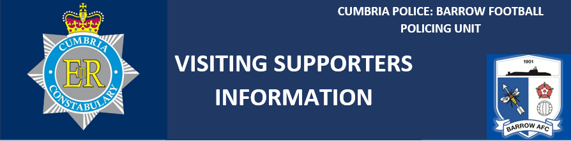

**Parking**

Official Buses can be accommodated around the ground if police have prior knowledge of how many coaches are travelling, to ensure that the space is reserved. The initial bus parking is marked with on the picture below.

There is car parking available at the “Soccer Bar” which is just before you arrive at the stadium on the right this holds around 60 car park spaces at a cost of £4 per car.

Please avoid parking at Asda due to the fact it is for patrons only, there is also a parking eye in operation.

**By Train**

Once you arrive at Barrow train station, if you turn right onto Holker Street, The Stadium is only a five-minute walk up the road. The away turnstiles are on the left just after the traffic lights at the end of the road. Please be aware the last train to leave Barrow heading south during midweek is around **2145** to Preston.

**SUPPORTERS** 

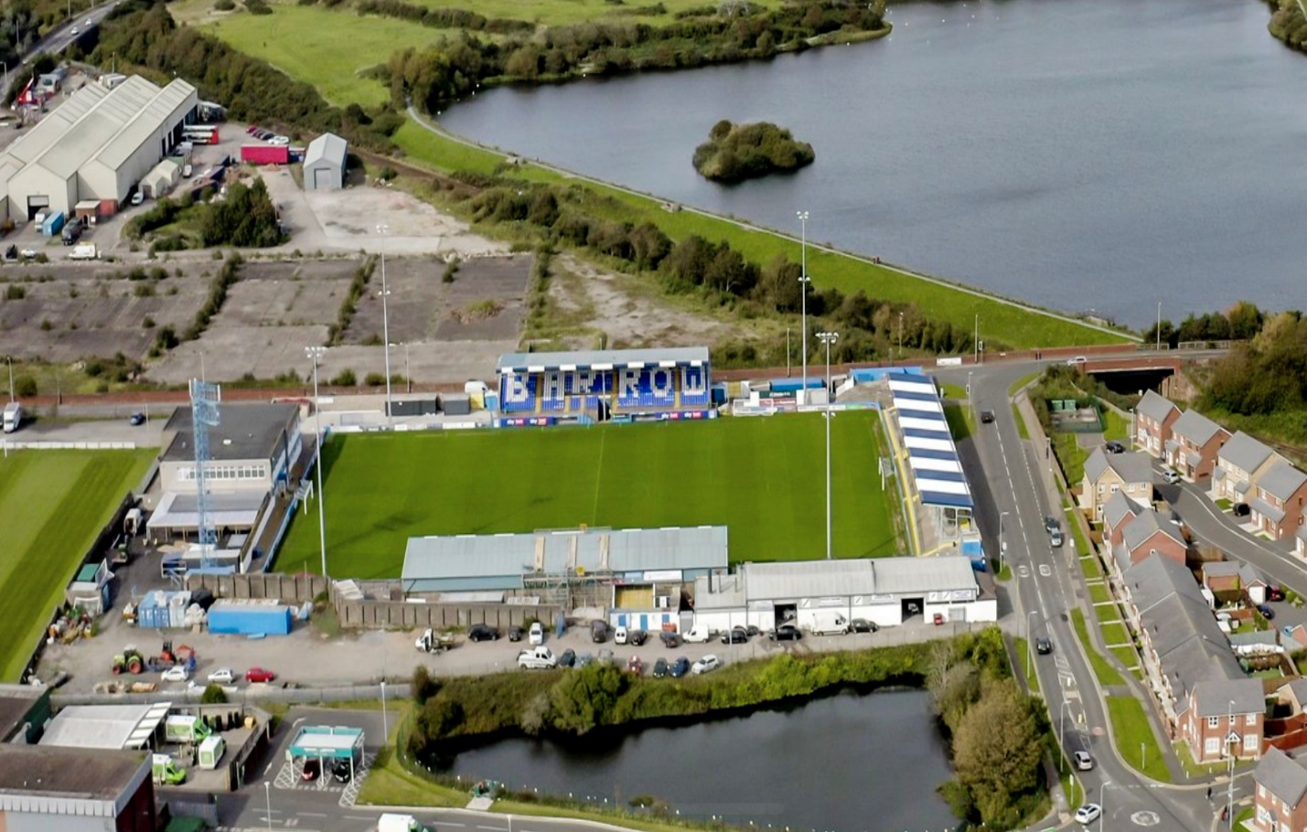

**TO A590**

**TO TRAIN STATION AND TOWN CENTRE**

**AWAY SUPPORTERS AREA**

**TICKET OFFICE AND MAIN RECEPTION**



**Refreshments at Holker street**

Located in the away end is the Bar and Food facility please be aware this isn’t covered so fans are advised to dress accordingly for the weather (its usually raining).

The bar serves draft Lager,Cider and Ale.

The food is usually pies, pasties and sausage rolls supplied by a local bakery.

Inside the stadium we accept cash or card.

Away fans will be welcome in the fan zone prior to the match starting subject to police recommendation, please confirm with the clubs SLO or Police liaison officer.

**Places to eat and drink**

**Hawcoat Park Sports Club located in Barrow would be happy to receive away supporters for drinks etc.**

**We have a large function room with a large tv with Sky Sports and Bt Sport.  
  
We also have a smaller upstairs lounge and we have disabled access.**

**My mobile number is 07881923523 if you need any more detail ask for Keith or Sam.**

The Ambrose Hotel (LA14 1XT) is a friendly pub and hotel only a ten-minute walk from the ground. It has all the usual satellite T.V and a pool table, with outdoor tables front and rear. If you want to book ahead, Lynda on 01229 826717

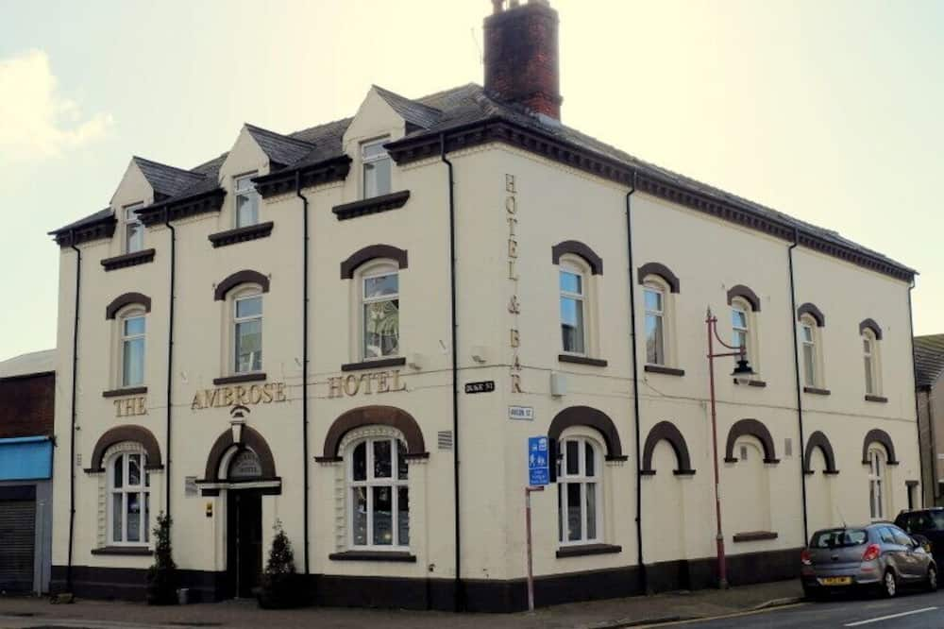

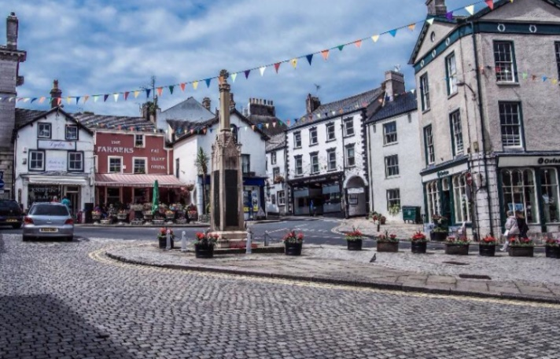Ulverston Town Centre.

Ulverston is a popular small market town, around a 20-minute drive from the stadium. There are numerous public Houses at this location but parking for busses can be an issue. Ringing up and giving the heads up to these Public Houses prior to your arrival is recommended, so they can accommodate you.

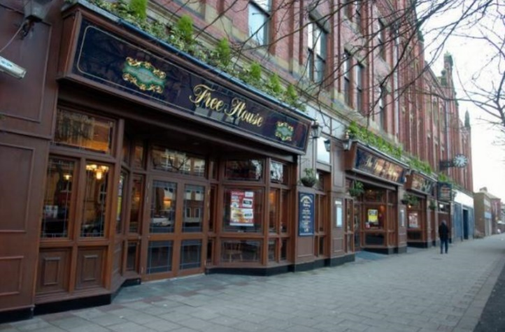The Furness Railway (Wetherspoons) is located just outside of Barrow railway station, on Abbey Road.

Parking at this location is non-existent.

If you chose to go here on mass, to make sure ample staff are on duty to stop you getting thirsty waiting, please email [p516@jdwetherspoon.co.uk](mailto:p516@jdwetherspoon.co.uk)

The Owl and the Pussycat (LA14 2NA) is a family friendly ‘Hungry Horse’ style pub with an extensive menu, good parking, and a soft play area. Phone 01229 824334. It is 15 minutes’ walk from the ground.

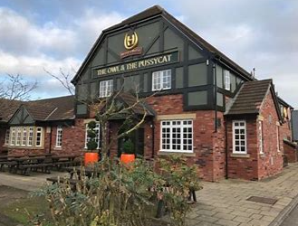

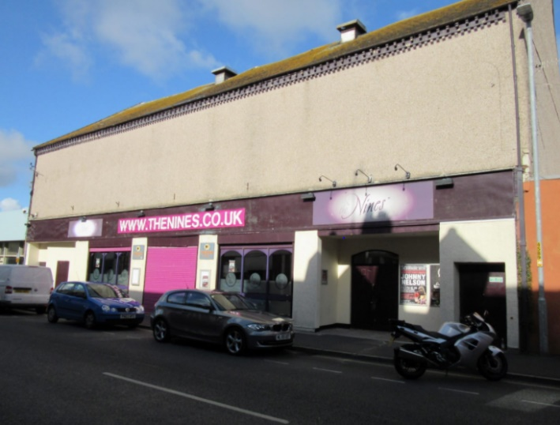The Lounge and Cloud 9 are happy to open the doors for groups of supporters if they want their own venue on the day. This bar is on Dalkeith Street (30 seconds walk from Wetherspoons)

Booking the venue prior to arrival is required.

I am happy to book/help assist booking any venues to make your visit to the Furness area more enjoyable.

Barrow Football Policing Unit have the facility to answer any football related questions you may have regarding your trip to Barrow. We can be found on Twitter on @BarPolBarrowAFC.

Have a safe trip and we hope you enjoy your day here!

Kind Regards

PC 2293 Rickie Wallbank

Dedicated Football Officer- Barrow AFC

[Rickie.Wallbank@Cumbria.police.uk](mailto:Rickie.Wallbank@Cumbria.police.uk)

Kane Ackred

Club Supporters Liaison officer

[SLO@Barrowafc.com](mailto:SLO@Barrowafc.com)